

**By - Satyajeet Ramnit**

**Business Report**

**(Project Report)**

**Content :**

**1) Introduction of the business problem**

a) Defining problem statement (Pg : 03)

b) Need of the study/project (Pg : 03)

c) Understanding business/social opportunity (Pg : 03)

**2)Data Report**

a) Understanding how data was collected in terms of time, frequency and

methodology (Pg : 03-04)

b) Visual inspection of data (rows, columns, descriptive details) (Pg : 04-05)

c) Understanding of attributes (variable info, renaming if required) (Pg : 05-10)

**3) Exploratory data analysis**

a) Univariate analysis (distribution and spread for every continuous attribute,

distribution of data in categories for categorical ones) (Pg : 10-12)

b) Bivariate analysis (relationship between different variables , correlations) (Pg : 12-17)

c) Removal of unwanted variables (if applicable) (Pg : 17)

d) Missing Value treatment (if applicable) (Pg : 18-19)

e) Outlier treatment (if required) (Pg : 19-23)

f) Variable transformation (if applicable) (Pg : 22-23)

g) Addition of new variables (if required) (Pg : 23)

**4) Business insights from EDA**

a) Is the data unbalanced? If so, what can be done? Please explain in the context

of the business (Pg : 23-24)

b) Any business insights using clustering (if applicable) (Pg : 25-26)

c) Any other business insights (Pg : 26-27)

**1) Introduction of the business problem**

**a) Problem statement**

The major objective of this data set is to extract actionable insights from the leading life insurance company data and make strategic changes to make the company grow. Primary objective is to create Machine Learning models which correctly predicts the bonus for its agents so that it may provide information regarding high performing agents and low performing agents. Once a model is developed then it can extract actionable insights and recommendation, so based of which the company may design appropriate engagement activity and up skill programs for their agents as required.

**b) Need of the study/project**

Based on their agents to sell the policies, the insurance companies are heavily dependent on their success. So, it becomes very crucial to find and design engagement activity for their high performing agents giving them more and more incentives to keep up their performance and achieve more and also, up skill programs for their low performing agents to get better and perform better, and such that all together their agents are more able to sell the quality insurance to their customers and add more greater value to the company. And through this project with the help of data and its analysis help the insurance company to make data-driven business decisions. It empowers companies with high-level data and information that is leveraged into improved insurance processes and new opportunities.

Basically the need of this data study here is Bonus prediction of the employees. Help the company to conduct proper skill engaging activities for well performing agents. Help the company to conduct proper upskill activities for under performing agents. These programs will help the company to increase skilled employment.

**c) Understanding business / social opportunity**

Usually businesses benefit to the extent that they stay close to customers. Traditionally, the insurance company has relied on strong networking and trusted relationships. By transforming into social businesses, insurers can tap significant opportunities that enable them to generate more demand, win customer loyalty and maximize returns.

1. **Data Report**
2. **Understanding how data was collected in terms of time, frequency and methodology**

The data belongs to a leading life insurance company. The agent’s different sales data based on the customers’ varied attributes like age, tenure in organization, channel through which acquisition is done, their occupation, education, Designation Marital status, Gender, their location, complaint registered, income, customer satisfaction score, all collected in the course of time they were with the company. Certain attributes leading to the Agent’s bonus are also captured.

|  |  |
| --- | --- |
| **Variable** | **Discerption** |
| CustID | Unique customer ID |
| AgentBonus | Bonus amount given to each agents in last month |
| Age | Age of customer |
| CustTenure | Tenure of customer in organization |
| Channel | Channel through which acquisition of customer is done |
| Occupation | Occupation of customer |
| EducationField | Field of education of customer |
| Gender | Gender of customer |
| ExistingProdType | Existing product type of customer |
| Designation | Designation of customer in their organization |
| NumberOfPolicy | Total number of existing policy of a customer |
| MaritalStatus | Marital status of customer |
| MonthlyIncome | Gross monthly income of customer |
| Complaint | Indicator of complaint registered in last one month by customer |
| ExistingPolicyTenure | Max tenure in all existing policies of customer |
| SumAssured | Max of sum assured in all existing policies of customer |
| Zone | Customer belongs to which zone in India. Like East, West, North and South |
| PaymentMethod | Frequency of payment selected by customer like Monthly, quarterly, half yearly and yearly |
| LastMonthCalls | Total calls attempted by company to a customer for cross sell |
| CustCareScore | Customer satisfaction score given by customer in previous service call |

1. **Visual inspection of data (rows, columns, descriptive details)**

RangeIndex: 4520 entries, 0 to 4519

Data columns (total 20 columns):

# Column Non-Null Count Dtype

--- ------ -------------- -----

0 CustID 4520 non-null int64

1 AgentBonus 4520 non-null int64

2 Age 4251 non-null float64

3 CustTenure 4294 non-null float64

4 Channel 4520 non-null object

5 Occupation 4520 non-null object

6 EducationField 4520 non-null object

7 Gender 4520 non-null object

8 ExistingProdType 4520 non-null int64

9 Designation 4520 non-null object

10 NumberOfPolicy 4475 non-null float64

11 MaritalStatus 4520 non-null object

12 MonthlyIncome 4284 non-null float64

13 Complaint 4520 non-null int64

14 ExistingPolicyTenure 4336 non-null float64

15 SumAssured 4366 non-null float64

16 Zone 4520 non-null object

17 PaymentMethod 4520 non-null object

18 LastMonthCalls 4520 non-null int64

19 CustCareScore 4468 non-null float64

dtypes: float64(7), int64(5), object(8)

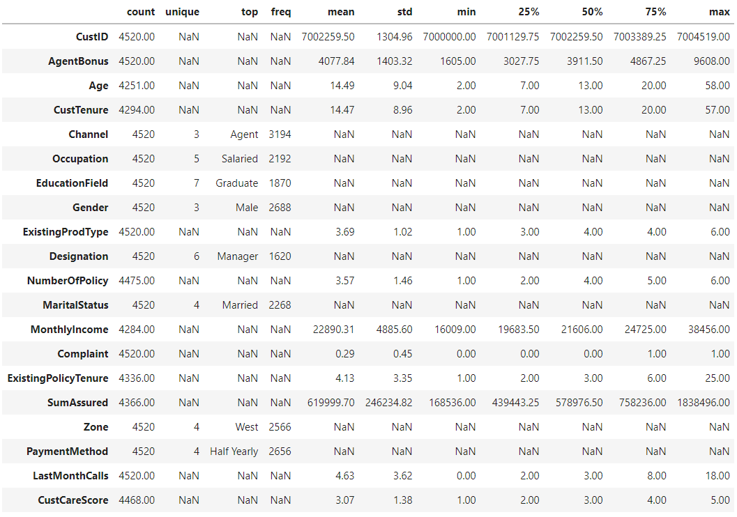

1. **Understanding of attributes (variable info, renaming if required)**

*1. CustID- Unique customer ID*

*4520 unique customer IDs present ranging from 7000000 to 7004519 (both inclusive).*

*2. AgentBonus- Bonus amount given to each agents in last month*

*Amount ranging inclusively between 1605 to 9608. A major difference is seen portraying the gap*

*between high performing agents and low performing agents.*

*3. Age- Age of customer*

*Customers’ age ranging inclusively between 2 years to 58 years. I found that this column requires*

*missing value treatment.*

*4. CustTenure- Tenure of customer in organization*

*Customers’ tenure ranging inclusively between 2 years to 57 years. I found that this column requires*

*missing value treatment.*

*5. Channel- Channel through which acquisition of customer is done*

*3 Channels are there agent, online, and third party in which agent is the most preferred one.*

*6. Occupation- Occupation of customer*

*Salaried customers are the most valued for the company. Also “Laarge Business” values were mistyped so corrected them as “Large Business”.*

*7. EducationField- Field of education of customer*

*Graduated customers are the most valued for the company followed by undergraduated with minimum*

*being MBA.*

*8. Gender- Gender of customer*

*The Number of males is greater than females. Also “Fe male” was mistyped and it was replaced with*

*“Females”.*

*9. ExistingProdType- Existing product type of customer*

*Here product type could be policy type since it’s an insurance company data. Maximum customers have enrolled themselves in policy number 4.*

*10. Designation- Designation of customer in their organizationNumberOfPolicy- Total number of*

*existing policy of a customer The Number of customers designated as managers is the greatest.*

*11. NumberOfPolicy- Total number of existing policy of a customer*

*Customers having 4 existing policies is the maximum.*

*12. MaritalStatus- Marital status of customer*

*Married customers are most valuable to the company while unmarried being the least.*

*13. MonthlyIncome- Gross monthly income of customer*

*Monthly income of customers is very much scattered.*

*14. Complaint- Indicator of complaint registered in last one month by customer*

*Most of the customers have zero complaints while around 1200 have 1 complaint each.*

*15. ExistingPolicyTenure- Max tenure in all existing policies of customer*

*Most of the customers prefer a 5 years tenure. Though 25 is the maximum tenure any customer has.*

*16. SumAssured- Max of sum assured in all existing policies of customer*

*This column needs missing value treatment. Also the columns’ values are scattered within a specific*

*range.*

*17. Zone- Customer belongs to which zone in India. Like East, West, North and South*

*Northern customers are most valuable to the company while southern customers are the minimum.*

*18. PaymentMethod- Frequency of payment selected by customer like Monthly, quarterly, half yearly*

*and yearly Maximum customers prefer to pay half yearly while very less prefer quarterly.*

*19. LastMonthCalls- Total calls attempted by company to a customer for cross sell*

*Maximum customers are attended by agents.*

*20. CustCareScore- Customer satisfaction score given by customer in previous service call*

*Maximum customers rated 5/5 for the company.*

***The name of the columns seems to be fine with no special characters or spaces between them.***

***Unique values of various Categories :***

Channel : 3

Online 468

Third Party Partner 858

Agent 3194

Name: Channel, dtype: int64

Occupation : 5

Free Lancer 2

Laarge Business 153

Large Business 255

Small Business 1918

Salaried 2192

Name: Occupation, dtype: int64

EducationField : 7

MBA 74

UG 230

Post Graduate 252

Engineer 408

Diploma 496

Under Graduate 1190

Graduate 1870

Name: EducationField, dtype: int64

Gender : 3

Fe male 325

Female 1507

Male 2688

Name: Gender, dtype: int64

Designation : 6

Exe 127

VP 226

AVP 336

Senior Manager 676

Executive 1535

Manager 1620

Name: Designation, dtype: int64

MaritalStatus : 4

Unmarried 194

Divorced 804

Single 1254

Married 2268

Name: MaritalStatus, dtype: int64

Zone : 4

South 6

East 64

North 1884

West 2566

Name: Zone, dtype: int64

PaymentMethod : 4

Quarterly 76

Monthly 354

Yearly 1434

Half Yearly 2656

Name: PaymentMethod, dtype: int64

***The highlighted data seems to be recorded incorrectly and required replacement and this was done to ensure the right categories are picked up by the model***

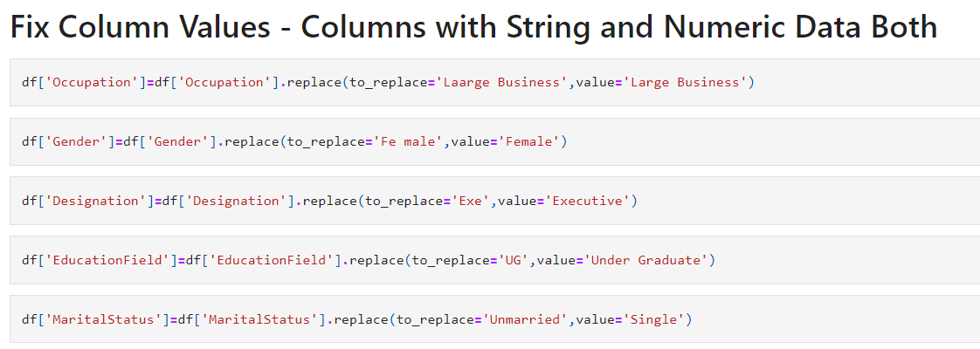

***Post fixing of the data :***

Channel : 3

Online 468

Third Party Partner 858

Agent 3194

Name: Channel, dtype: int64

Occupation : 4

Free Lancer 2

Large Business 408

Small Business 1918

Salaried 2192

Name: Occupation, dtype: int64

EducationField : 6

MBA 74

Post Graduate 252

Engineer 408

Diploma 496

Under Graduate 1420

Graduate 1870

Name: EducationField, dtype: int64

Gender : 2

Female 1832

Male 2688

Name: Gender, dtype: int64

Designation : 5

VP 226

AVP 336

Senior Manager 676

Manager 1620

Executive 1662

Name: Designation, dtype: int64

MaritalStatus : 3

Divorced 804

Single 1448

Married 2268

Name: MaritalStatus, dtype: int64

Zone : 4

South 6

East 64

North 1884

West 2566

Name: Zone, dtype: int64

PaymentMethod : 4

Quarterly 76

Monthly 354

Yearly 1434

Half Yearly 2656

Name: PaymentMethod, dtype: int64

1. **Exploratory data analysis**
2. **Univariate analysis (distribution and spread for every continuous attribute, distribution of data in categories for categorical ones)**

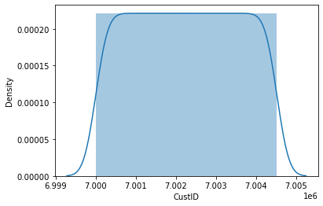 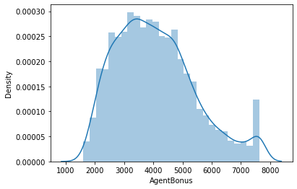

Right Skew

Continuous over a large range

Continuous

Right Skew

Continuous over a large range

Right Skew

Continuous over a large range

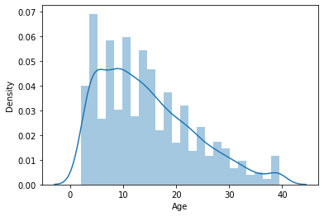 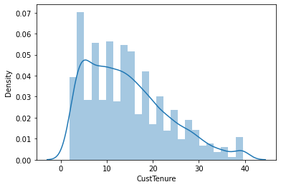

More Discrete Kind of data 4 is the most frequent observation

Continuous

Right Skewed

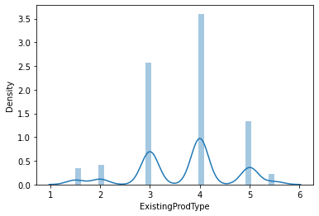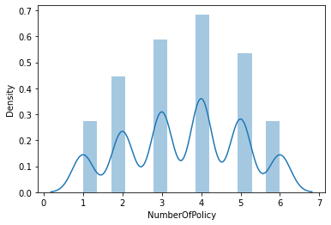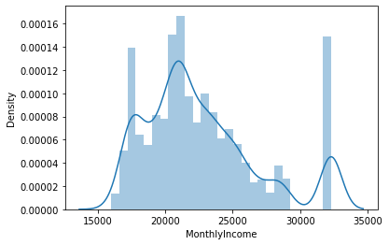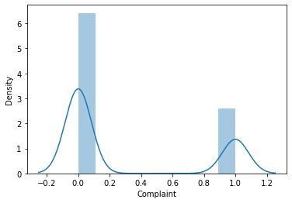

Discrete Values

Continuous in a range with two peak values.

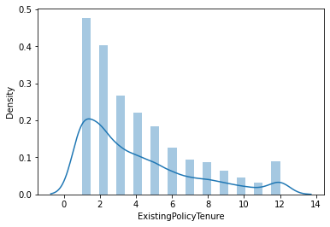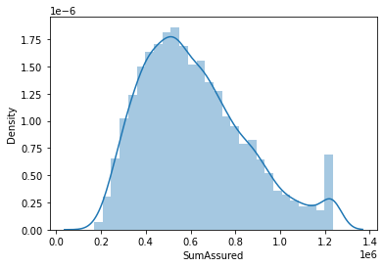

Right Skew

Continuous over a large range

Right Skew

Discrete Values

Discrete kind of data with 2 peak values in the range

More Discrete Kind of data. 3 is the most frequent observation

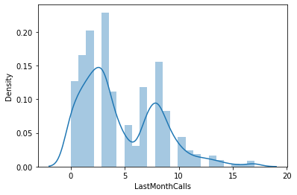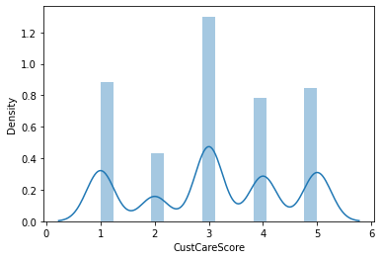

1. **Bivariate analysis (relationship between different variables , correlations)**

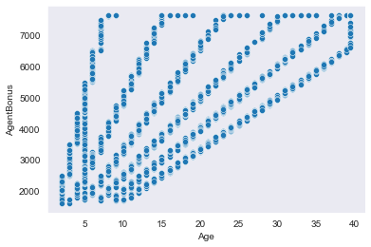 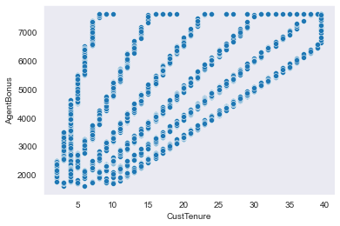

Positively Related

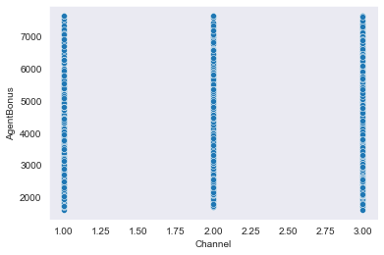 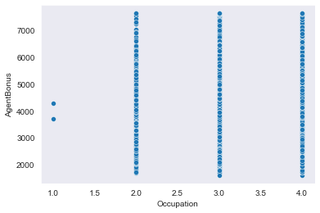

Not able to establish any relation between variables

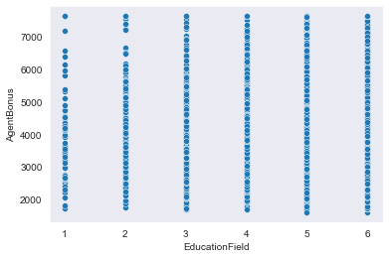 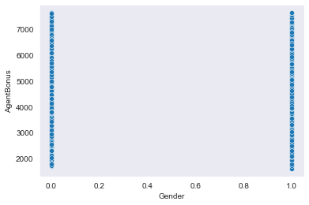

Not able to establish any relation between variables

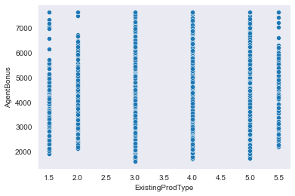 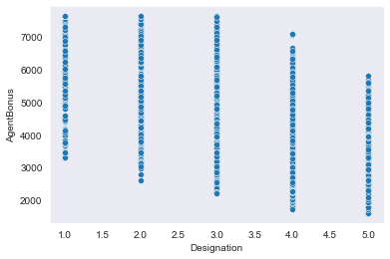

Not able to establish any relation between variables

Negatively Related

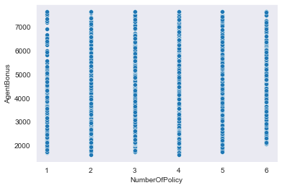 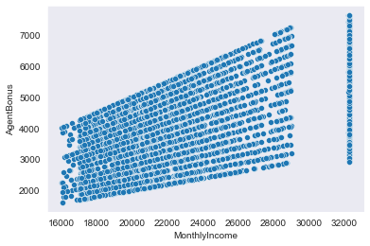

Positively Related

Not able to establish any relation between variables

Positively Related

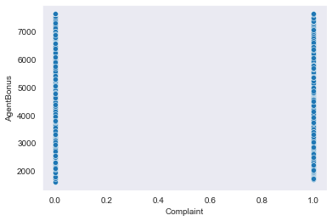 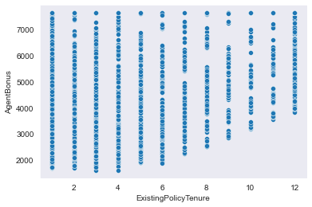

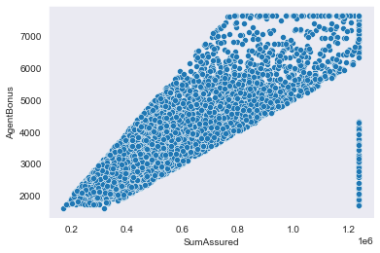 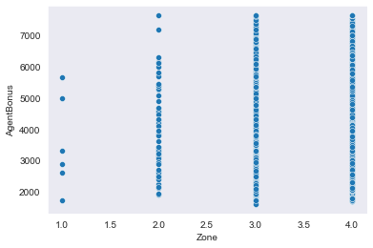

Positively Related

Not able to establish any relation between variables

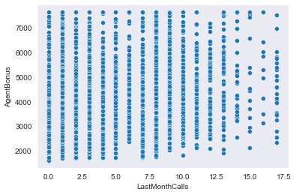 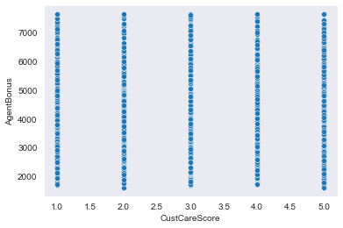

Not able to establish any relation between variables

*Most of the variables don’t seem to be related closely to each other which means there is low multi-collinearity in the data and each feature would have its importance in building the right model . because of this we have not dropped any columns and would want to build the model to see the variable importance.*

*The pair plot also seems to suggest the same thing . But due to the huge number of columns pair plot was not providing very clear insight and hence resorted to bi variate plots with every combination possible.*

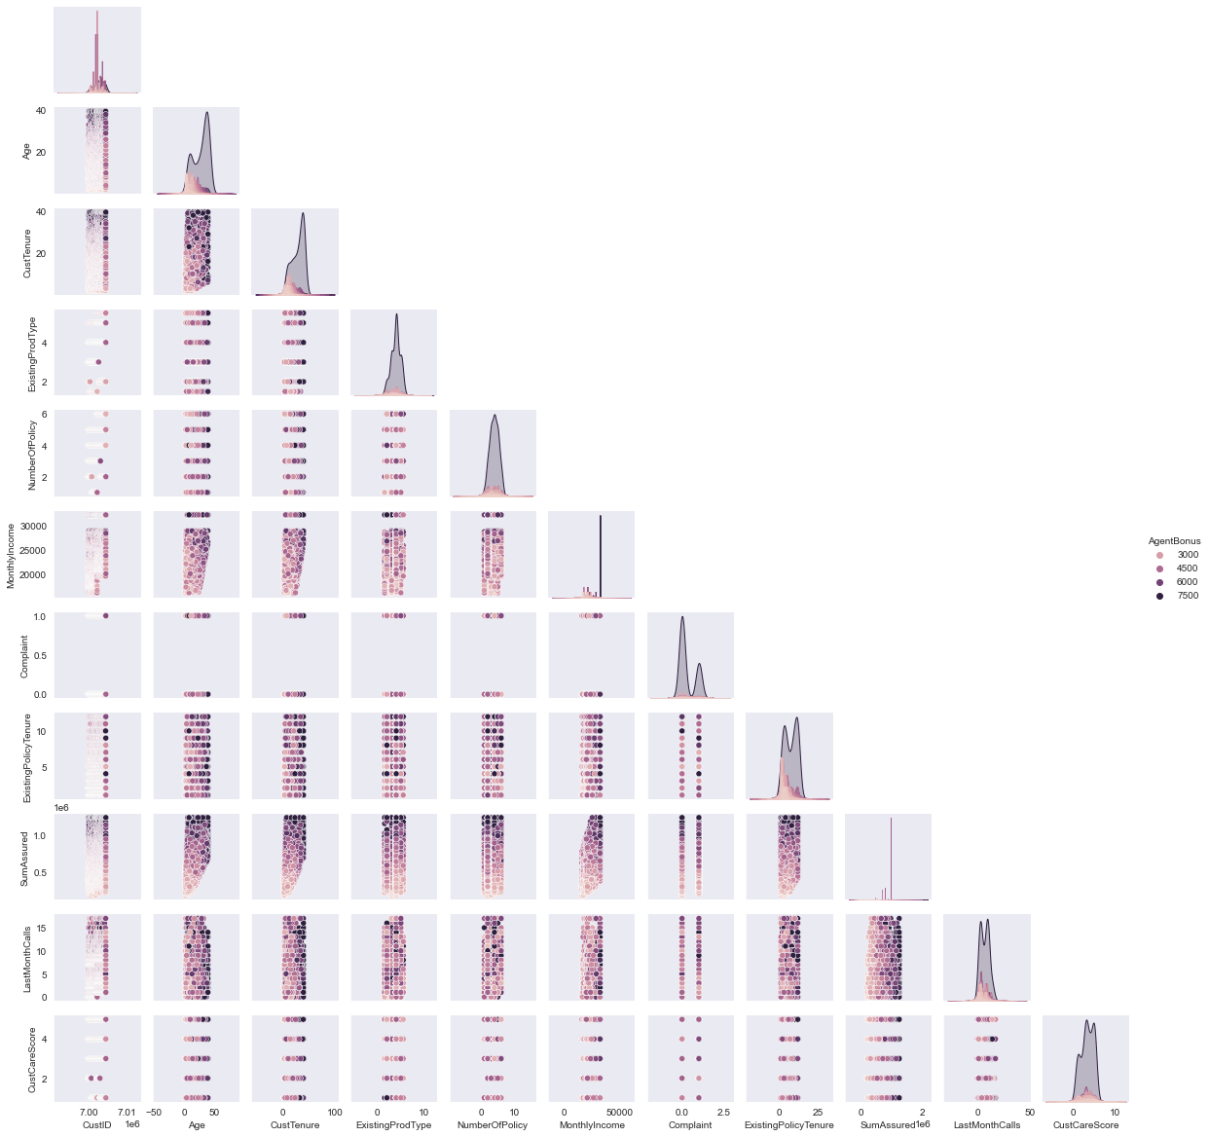

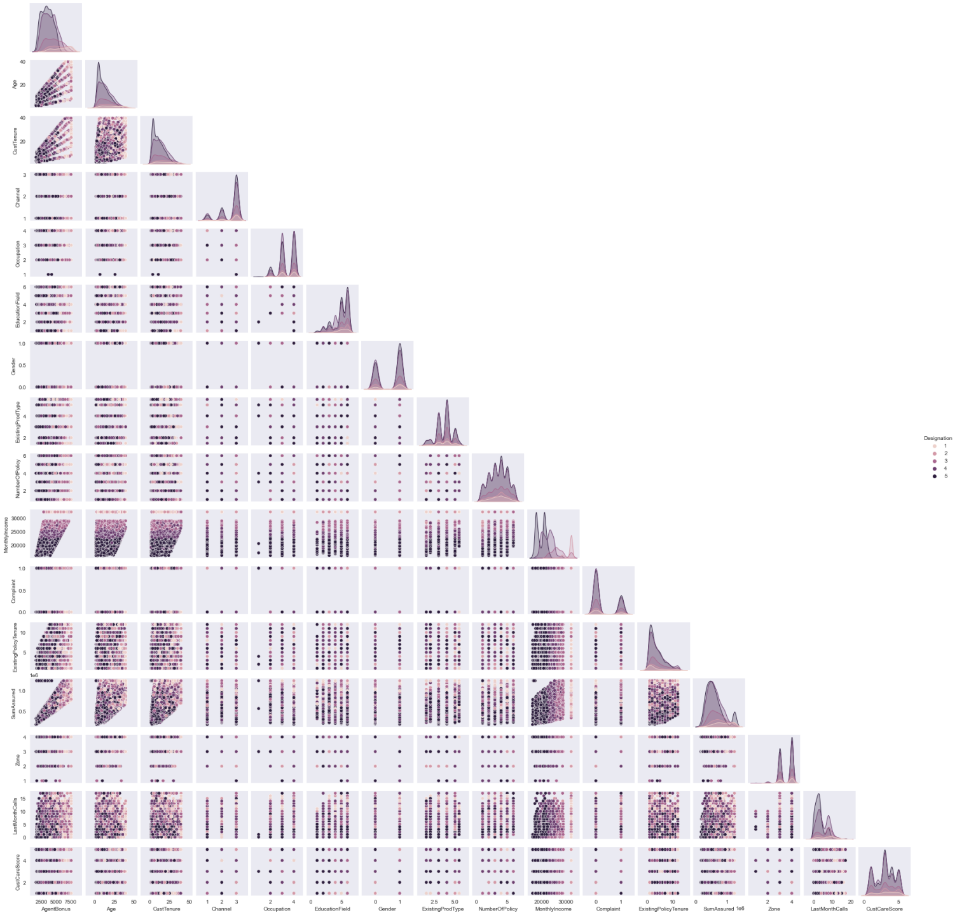

1. **Removal of unwanted variables**

In the dataset CustID, MaritalStatus and PaymentMethod are all redundant columns and thus have been removed. Chose not to remove any other columns and left to the model phase where the variable importance would be judged.

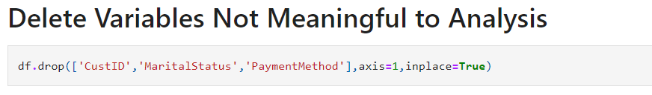

1. **Missing Value treatment**

There are 1166 missing values in the dataset :

Age 269

MonthlyIncome 236

CustTenure 226

ExistingPolicyTenure 184

SumAssured 154

CustCareScore 52

NumberOfPolicy 45

LastMonthCalls 0

Zone 0

Complaint 0

AgentBonus 0

ExistingProdType 0

Gender 0

EducationField 0

Occupation 0

Channel 0

Designation 0

dtype: int64

*The missing values have been treated with most frequent values than median for numeric data including categorical data . The main reason of choosing mode or most frequent entry was it was making more sense considering the sports domain to which the problem belongs . More so as we have been in the various plots as well the numeric data has discrete pattern due to which we treated them as categorical data.*

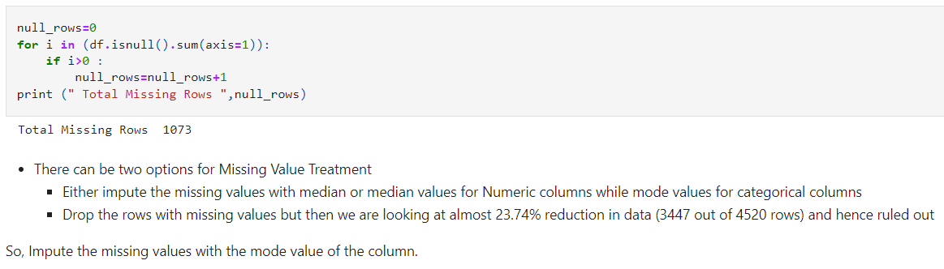

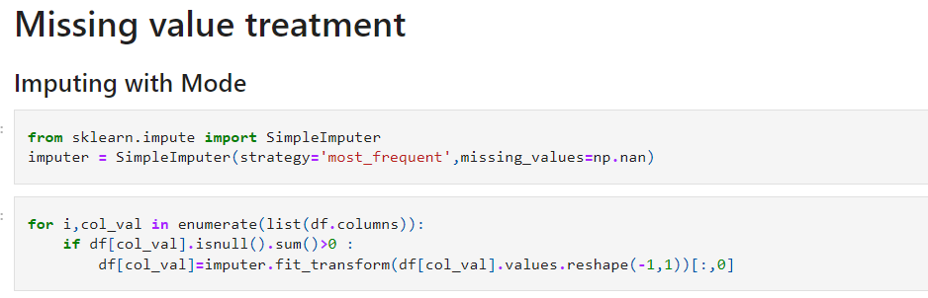

*After Treatment of missing value :*

AgentBonus 0

Age 0

CustTenure 0

Channel 0

Occupation 0

EducationField 0

Gender 0

ExistingProdType 0

Designation 0

NumberOfPolicy 0

MonthlyIncome 0

Complaint 0

ExistingPolicyTenure 0

SumAssured 0

Zone 0

LastMonthCalls 0

CustCareScore 0

dtype: int64

1. **Outlier treatment**

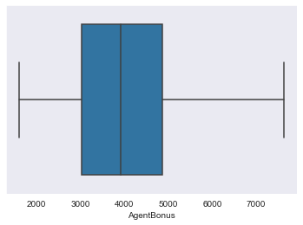 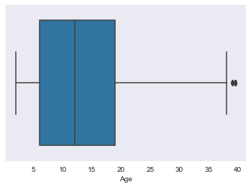

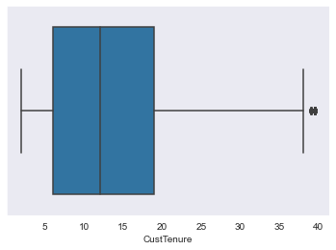 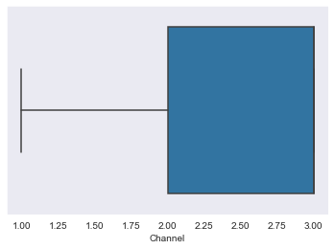

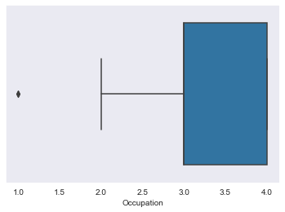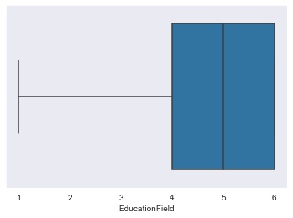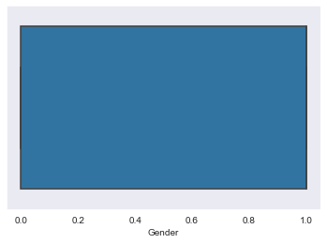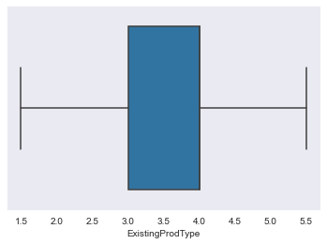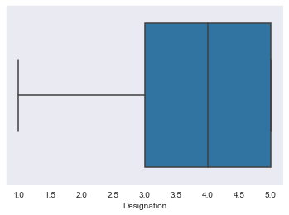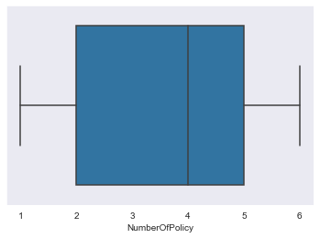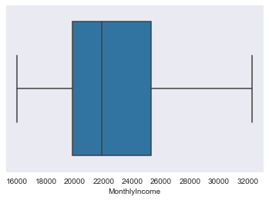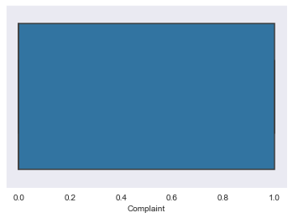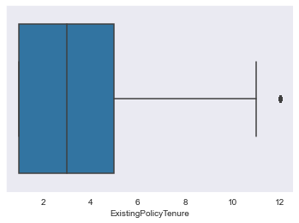

*Even though most of the numeric data here is discrete but few of the variables here are playing an important role in predicting the required value for the model which might get affected because of the outlying values, hence the outliers might reduce the value to the model. Like the age and customer tenure with the company which stands out while most of the others are in the right range.*

*So, in favour of doing the outlier treatment :*

*Detecting the Outliers*

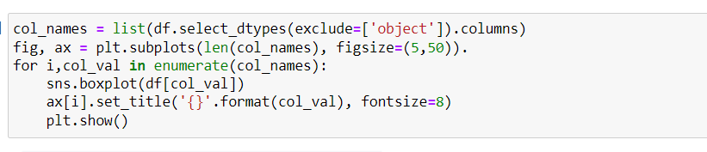

*Outlier Treatment :*

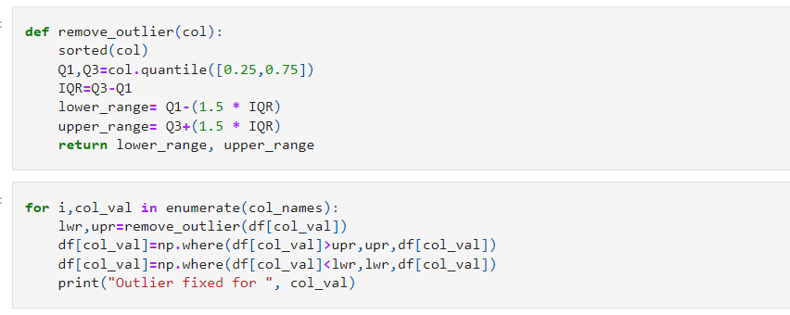

Outlier fixed for CustID

Outlier fixed for AgentBonus

Outlier fixed for Age

Outlier fixed for CustTenure

Outlier fixed for ExistingProdType

Outlier fixed for NumberOfPolicy

Outlier fixed for MonthlyIncome

Outlier fixed for Complaint

Outlier fixed for ExistingPolicyTenure

Outlier fixed for SumAssured

Outlier fixed for LastMonthCalls

Outlier fixed for CustCareScore

1. **Variable transformation**

*The variables has been encoded to numeric values for the following variables :*

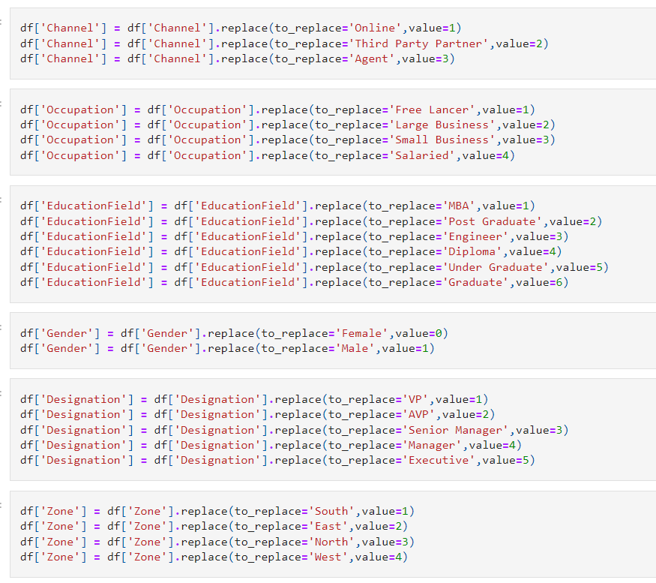

1. **Addition of new variables**

*No new variables were added at this stage . But before proceeding with the model one hot encoding would be required on few categories which would increase the number of column not essentially the number of variables.*

**4) Business insights from EDA**

**a) Is the data unbalanced? If so, what can be done? Please explain in the context of the business**

The data is balanced for most of the attributes given in the given data set, but for the remaining attributes the target variable has more observations in one specific class than the others. Our goal is to use techniques to cluster the sample into natural groups or to describe the relationship of the minority class with the features (independent variables), then this doesn’t pose a “huge” problem. It only becomes an issue when this “property” affects the performance of the algorithms or the models that you could obtain. If the classes are separable using the available features, then the distribution of the classes between them is not problematic.

To rectify this we can take following steps in the situation :

1. **Resample the dataset:**

* ***Undersampling***

*The idea is to reduce the ratio of instances in the majority and minority levels. You can randomly select observations in the desired ratio*

* ***Oversampling***

*We can create synthetical observations of the minority class based on the available data.*

* ***VAE***

*Variational Autoencoders allows us to explore variations in the current data, not just in a random way, but in the desired direction. For this task, VAE is a powerful method.*

1. **Collect more data from the minority class**

*This option appears trivial, but it solves the problem when it is applicable.*

1. **Use the “adequate” correct algorithm**

*Some algorithms are more robust than others. A mastery of the theory behind each algorithm will help us understand their strengths and weaknesses in various situations.*

1. **Change your approach**

*nstead of building a classifier, sometimes it is beneficial to change your approach and the scope ; one option would be to analyze your data from the ‘anomaly detection’ point of view.*

1. **Use penalized models**

*Many algorithms have their own penalized version. Usually, algorithms treat all misclassifications the same, so the idea is to penalize misclassifications from the minority class more than the majority.*

Also based on the data given we can predict the high performing agents and the low performing agents and the company could take any required option like upskilling them or to give more incentives and bonuses to the agents, for various attributes given to us in the dataset are corelated to the agent bonuses and hence performance. Through which the company could benefit a great value.

I think there should be more data for agent by which we can find which agent has more bonus and whose performance is high or low. Because in the dataset the given information are all about customers.

**b) Any business insights using clustering (if applicable)**

Salaried & small business have same range of bonus while large business a slightly lower value and freelancer fixed around a specific value

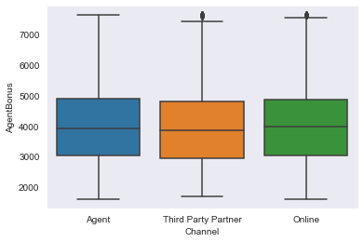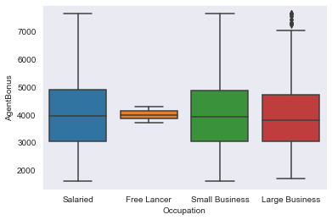

Gender has very less or no impact on the AgentBonus

Education has very less or no impact on the AgentBonus

Channel has very less or no impact on the AgentBonus

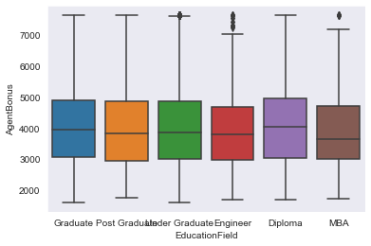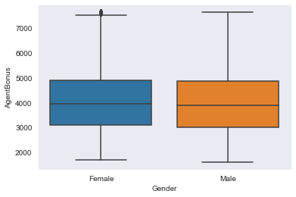

Marital Status has very less or no impact on the AgentBonus

The designation plays an important part in the bonus of the agent

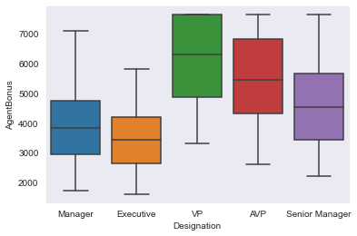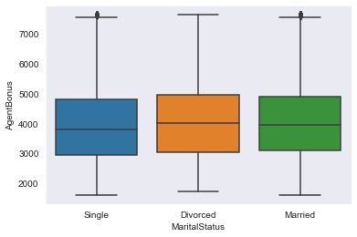

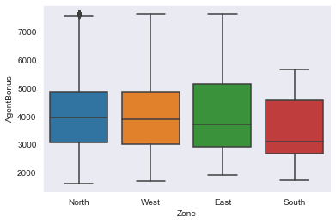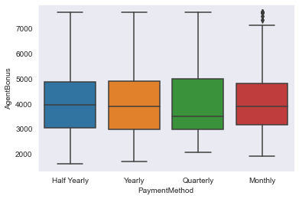

Varied for of pyments are used by the customers not impacting the agent bonus

South zone customers leads to a less bonus for the agent while east zone leads

We can make clusters of high performing agents and groups of low performing agents and put each agent in one of these group by collecting the data of their performance and can predict their bonus by which company can decide which group can take bonus and which group needs upskill program. Age, CustTenure, monthlyIncome, SumAssured seems to be correlated with AgentBonus which means with increase in age and then tenure of customer also increase in sumAssured and monthlyincome brings the best performance in an Agent, but may not be true for the everyone. Designation plays an negative role on the Agents Bonus as well. Various attributes like Marital status, gender have less or no impact on Agent performance.

1. **Any other business insights**

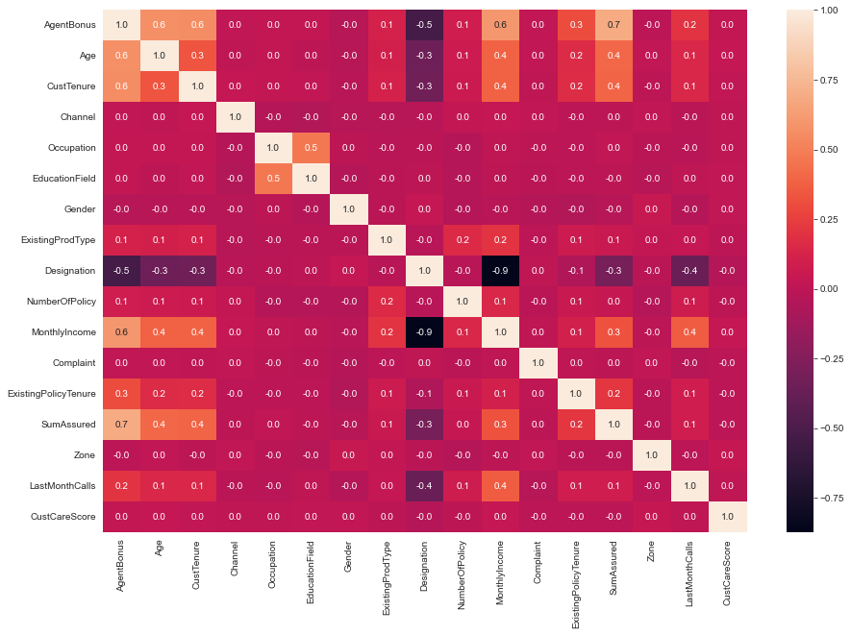

* Age, CustTenure, monthlyIncome, SumAssured seems to be correlated with AgentBonus which means with increase in age and then tenure of customer also increase in sumAssured and monthlyincome brings the best performance in an Agent, but may not be true for the everyone.
* Designation plays an negative role on the Agents Bonus as well as at monthlyIncome which means as move from VP towards Executive the Bonus and monthy income decreases.